LAB EXAM-2

AI ASSITED CODING,SET-H

HALLTICKET NO:2403A51235, NAME:A.HARSHAVARDHAN,

BATCH:11,

QUESTIONS:

### 1. H.1 — [S18H1] Extract hashtags and mentions

Context:

Moderation in real estate listings platform needs # and @ extraction.

Your Task:

Regex extract mentions/hashtags, lowercase lists.

Data & Edge Cases:

Ignore punctuation around tags.

AI Assistance Expectation:

Ask AI for regex and tests.

Constraints & Notes:

Return two lists.

Sample Input

Hello @alice check #AI and #Python with @Bob

Sample Output

mentions=['alice','bob'], hashtags=['ai','python']

Acceptance Criteria: Normalized lowercase; ignores punctuation

ANSWER:

PROMPT:

*I want to practice two Python problems for my lab:*

*1) Extract hashtags and mentions*

*Function: extract_mentions_hashtags(text)*

*1.It should return two lists: mentions and hashtags (all lowercase).*

*2. Ignore punctuation, like if text has "@John," or "#Deals!".*

*Example: "Hello @alice check #AI and #Python with @Bob"*

*Output should be: (['alice','bob'], ['ai','python']) , Please also add a couple of test cases at the end for this function.*

CODE:

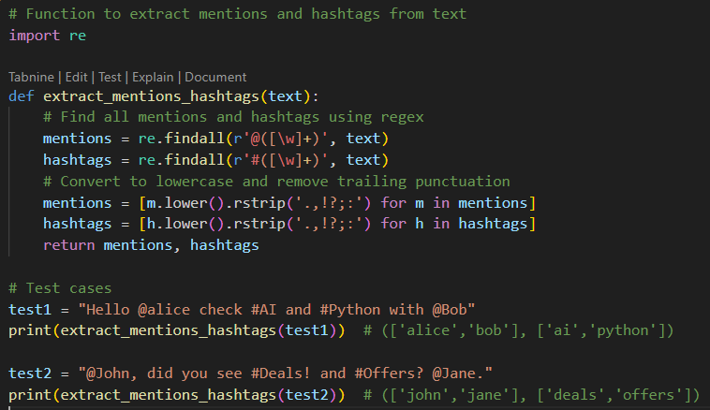

OUTPUT:

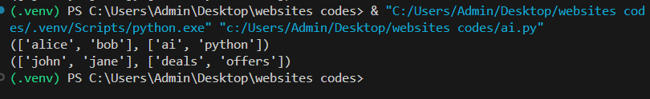

QUESTION:

### H.2 — [S18H2] Shortest path on weighted graph (Dijkstra)

Context:

Routing in real estate listings platform needs shortest paths.

Your Task:

Dijkstra from 'A' using heapq.

Data & Edge Cases:

Positive weights adjacency dict.

AI Assistance Expectation:

Use AI to outline relaxations.

Constraints & Notes:

Return distances dict.

Sample Input

{'A':{'B':1,'C':4},'B':{'C':2,'D':5},'C':{'D':1},'D':{}}

Sample Output

{'A':0,'B':1,'C':3,'D':4}

Acceptance Criteria: Correct distances

ANSWER:

PROMPT:

*2) Shortest path with Dijkstra*

*Function: dijkstra(graph, start)*

*Input: adjacency dictionary with positive weights*

*Use heapq for priority queue*

*Output: dictionary of shortest distances*

*Example:*

*graph = {'A':{'B':1,'C':4},'B':{'C':2,'D':5},'C':{'D':1},'D':{}}*

*start = 'A'*

*Expected: {'A':0,'B':1,'C':3,'D':4}*

*Please also add a couple of test cases at the end for this function.*

CODE:

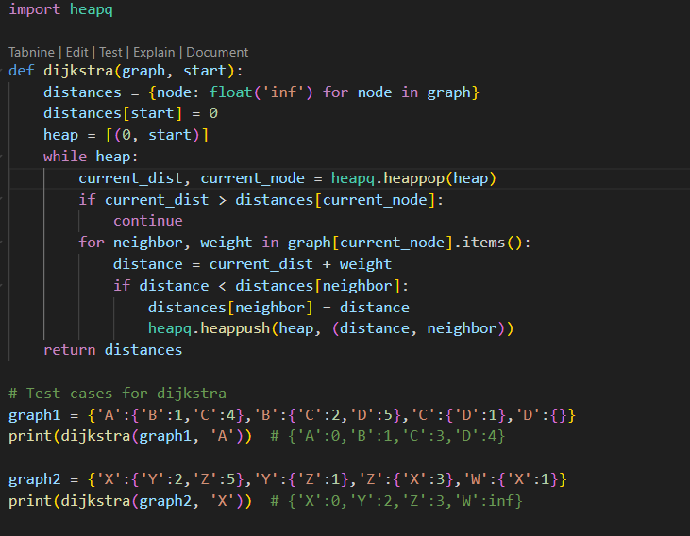

OUTPUT:

